**EXP NO 1 - FLIGHT RESERVATION SYSTEM**

**Aim:**

To create an application form for the flight reservation system by using zoho application.

**Material:**

● ZOHO software.

● Data.

**Procedure:**

**Step 1:**

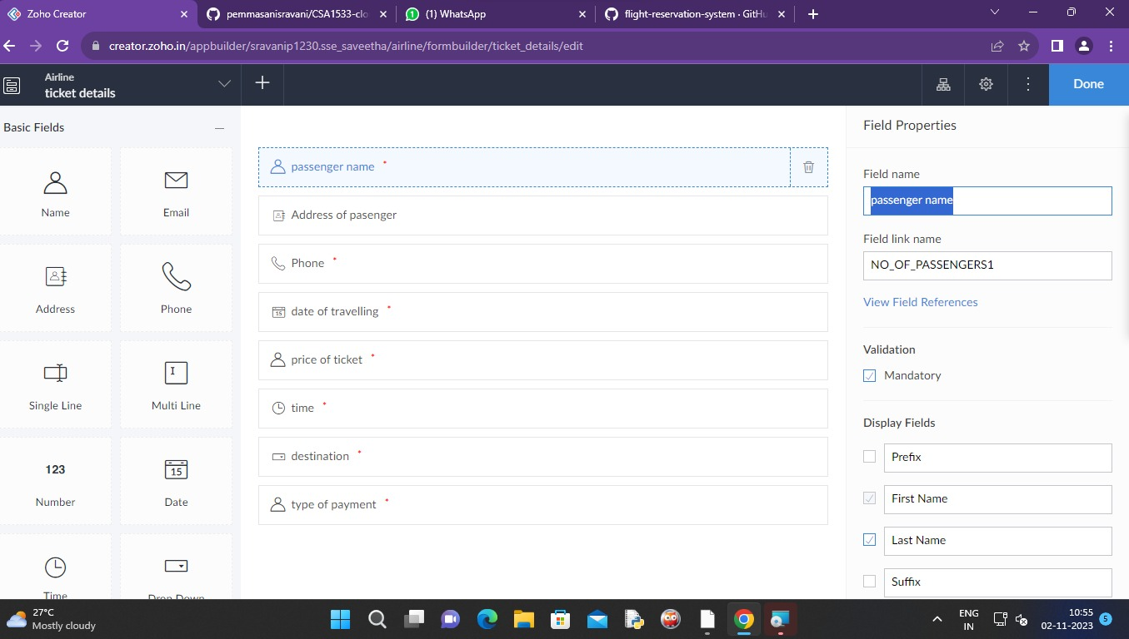

**Step 2:**

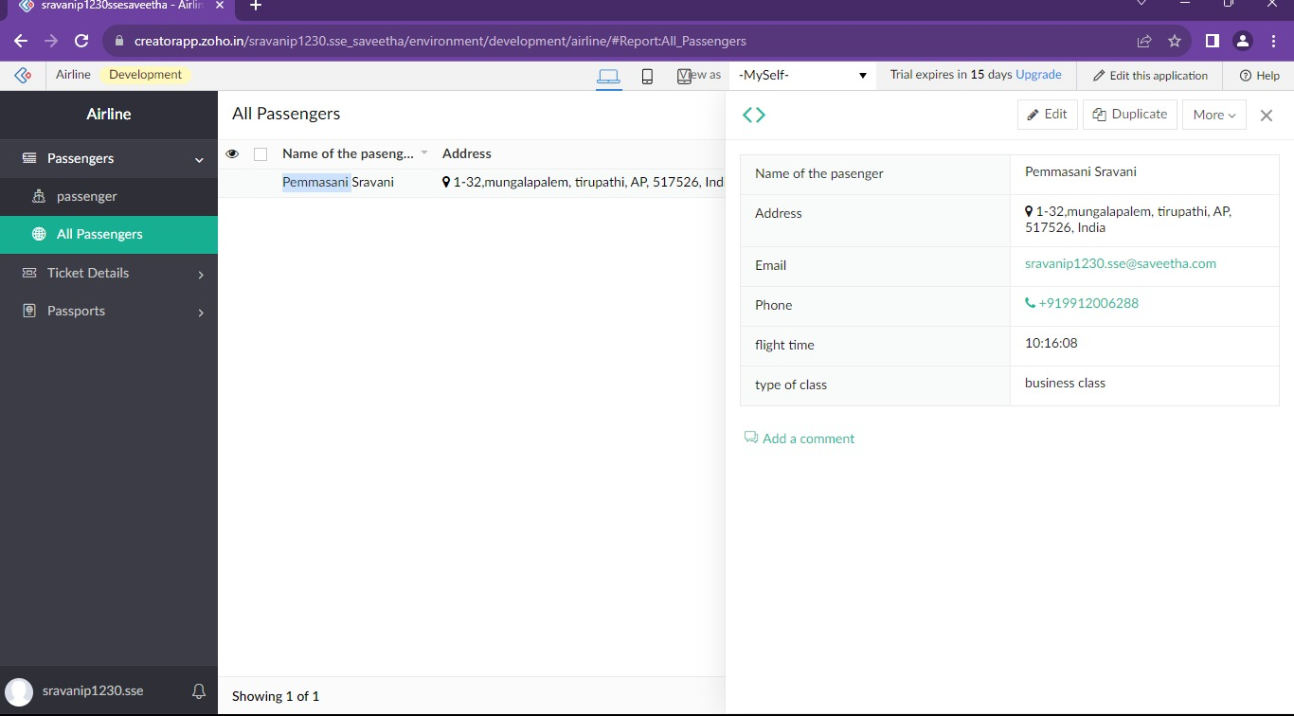

**Step 3:**

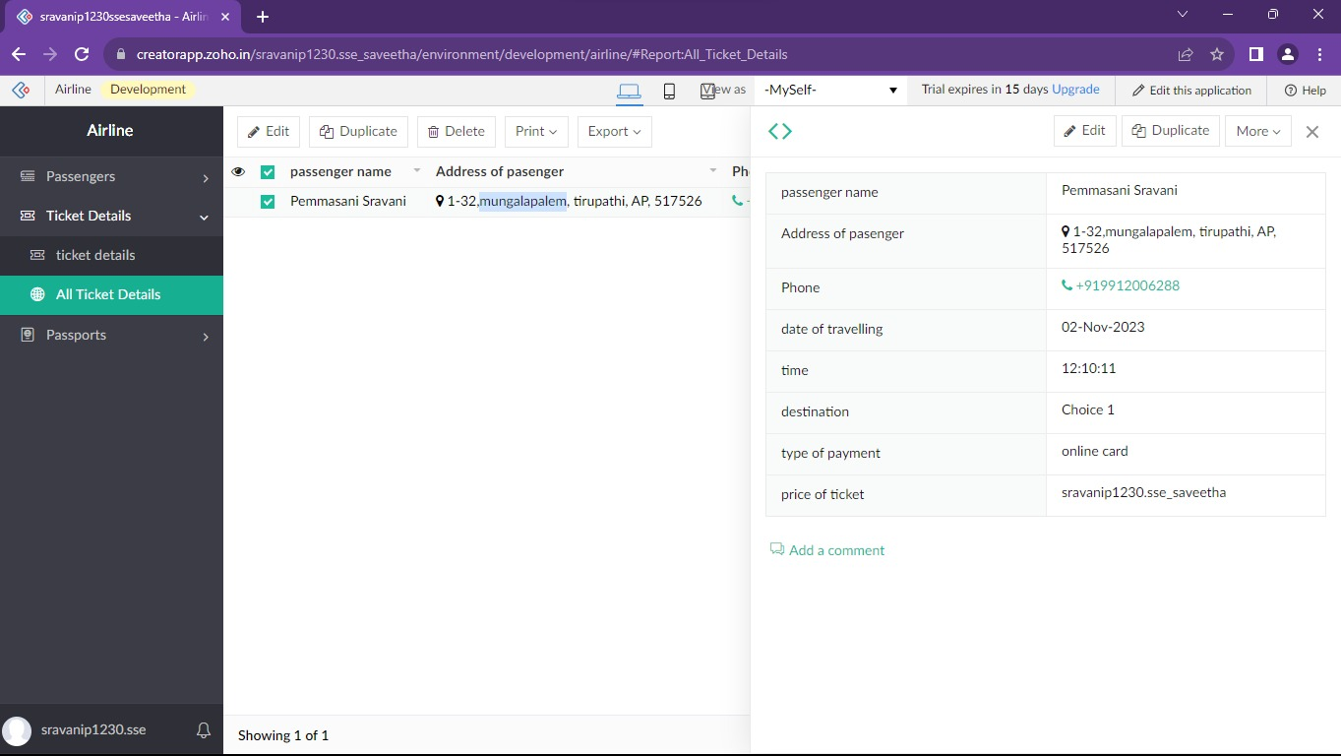

**Step 4:**



**Result:**

Successfully created a form for tickets reservation system by using ZOHO application.